|  |  |  |  |
| --- | --- | --- | --- |
| **TITLE:** | Inventory Control - Cycle Count | | |
| **sop #:** | IT-04 | **revision #:** | 1 |
| **EFFECTIVE DATE:** |  | | |
| **OWNER:** | Student05 | | |

## REVIEWERS

|  |  |  |  |
| --- | --- | --- | --- |
| Name | tITLE | sIGNATURE | dATE |
| Kazi Islam | Business Intelligence Developer and Analyst |  |  |

## APPROVER

|  |  |  |  |
| --- | --- | --- | --- |
| Name | tITLE | sIGNATURE | dATE |
| Elhadj Diallo | Business Intelligence Developer and Analyst |  |  |

# 1.0 purpose

To establish and maintain an effective inventory control activity at Radiant, Courtneypark facility. To provide guidance on inventory control personnel with an effective procedure in managing warehousing operations.

The purpose of this document is to be used as a training tool for all Radiant employees that are responsible and perform the task as assigned.

# 2.0 SCOPE

The following document covers the inventory control activities that take place in Radiant Global Logistics at 1280 Courtneypark Dr. E. This document covers the physical inventory control within the warehouse.

# 3.0 equipment

Designates must wear appropriate PPE, such as safety shoes, harness, reflective vest, safety goggles etcetera, as instructed.

# 4.0 definitions

|  |  |
| --- | --- |
| **Definition** | **Explanation** |
| **Bin** | A systematic and physical location where the product resides in the warehouse |
| **Electronic Data Interchange (EDI)** | EDI is the computer to computer or system to system transfer of business documents in a standard electronic format between Wheels and its customers |
| **Shipment Date / Lot & Expiry** | Products with Lot number and Expiry Date closest to current date are usually shipped first, and processed by province, unless otherwise requested by customers. |

# 5.0 Responsibility

|  |  |
| --- | --- |
| **Responsibility** | **Activity** |
| **Inventory Control Personnel** | * Ensure that products are properly located * Ensure that the inventory counts are accurate * Enter information in WMS accurately and in timely manner |
| **Inventory Control Supervisor** | * Ensure that inventory control personnel are complying with inventory rules and procedures * Ensure that controls in inventory are properly implemented * Ensure that physical and system information are aligned and accurate |
| **Distribution Manager** | * Also, known in this process as “Warehouse Manager” * Ensure that all warehouse personnel executing this process have been adequately trained and that the process is being followed. * That this procedure is regularly revisited and updated due to, but not limited to, the following reasons: risk identified, health and safety considerations, and stakeholders needs. |
| **Distribution Manager** | * Also, known in this process as “Warehouse Manager” * Ensure that all warehouse personnel executing this process have been adequately trained and that the process is being followed. * That this procedure is regularly revisited and updated due to, but not limited to, the following reasons: risk identified, health and safety considerations, and stakeholders needs. |

# 6.0 policy

## 6.1 MANUAL PROCESS

1. The Cycle Count Schedule is created and maintained by the IC Supervisor & Order Control Supervisor, depending on customers and their requirements, or as RGL requires
2. Using Navision, IC Supervisor or designate will:
3. Identify the SKUs that should be cycle counted.
4. Populate SKU information (Item No. and UPC) and their bin locations in form OPS08 – QF20. ‘First Count Sheet’
5. Controller will assign counters to conduct a blind count using ‘OPS08 – QF20’

Note: For detailed instructions on how to do this, refer to Annex – System Process

Note: Counter is the individual who conducts physical count of product.

1. Controller is the individual who hands out count sheets to different counters, and receives them back. Supervisor or designate can be controllers as well.
2. Designate is the individual authorized by Inventory Control Supervisor to conduct item investigations.
3. Bin Location and Item No. will already be populated (in step 2), so counters will note down the following:
   1. Date (top right of form)
   2. Quantity found in bin in field ‘1st Count’
   3. Once all items are counted, counter to sign at bottom left of form (Employee signature)

Note: Once done, return form to the controller.

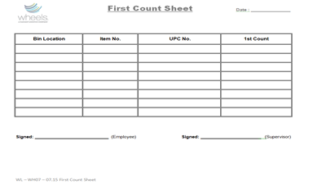

1. IC Supervisor, Designate, or Controller to:
2. Compare Quantity in 1st Count with Quantity in the system
3. If Quantity matches inventory in the system, proceed to Step 5
4. In case of discrepancies, go to Step 6.
5. When Quantity on Form OPS08 - QF20 matches the WMS inventory count, IC Supervisor to:
   1. Sign off on Form OPS08 - QF20
   2. If Physical and system quantity matches for all items in the form, physical paperwork is handed to specific office personnel.
   3. Office Personnel to index and scan documents to Transflo
   4. End of Process.

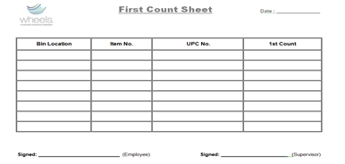

1. If physical count did not match system for all items on Form, proceed to next step.
2. When there are discrepancies between Quantity on OPS08 - QF20 versus the record on WMS, then the inventory controller will proceed with the following task:
   1. Put together Form # OPS08 - QF21 ‘Second Count Sheet’
   2. Ensure that Bin Location, Item No, and UPC fields are populated.
   3. Ask a different counter to conduct a second blind count.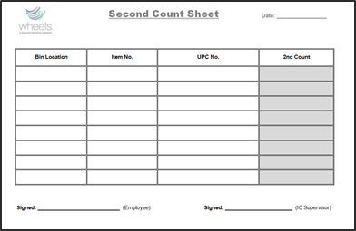
3. Different Counter will:
   1. Conduct blind count per instructions in Step 3 except that, for this form, write quantity in column “2nd Count”.
   2. Return form to controller when done.
4. If the second count remains incorrect, controller to:
   1. Log information on Form OPS08 – QF18 ‘Inventory Count Exception’
   2. Escalate issues to Inventory Control Supervisor or designate for further investigation

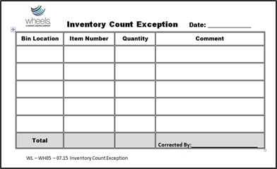

1. IC Supervisor or designate to:
   1. Review Form OPS08 – QF18
   2. Conduct investigation to determine cause of discrepancy
   3. When required, adjust product in/out to make system inventory match physical.
   4. See Process OPS08 - 21 ‘Inventory Control Adjustments’ for more detail.

## 6.2 System process

1. Go to Whse. Phys. Invt. Journals.
2. Warehouse → Goods Handling Multiple Orders → Periodic Activities → Whse. Phys. Invt. Journals
3. This brings up Whse. Phys. Invt. Journal

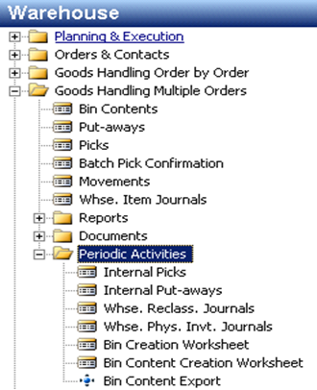

1. In Journal, go to: Functions → Calculate Inventory

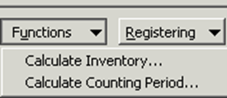

1. Enter the item number on ‘Item No.’ field

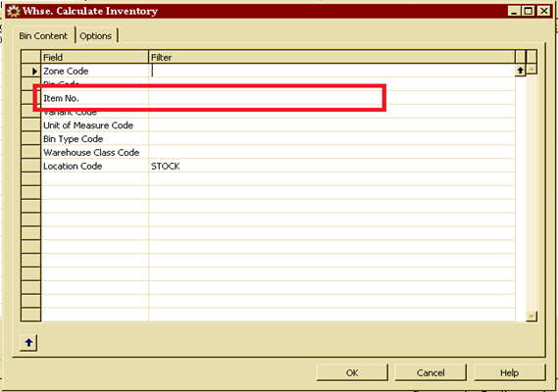

1. Screen will automatically populate all the required entries sorted by ‘BIN’ on the journal.

NOTE: this journal will be the reference spreadsheet for physical counting of products

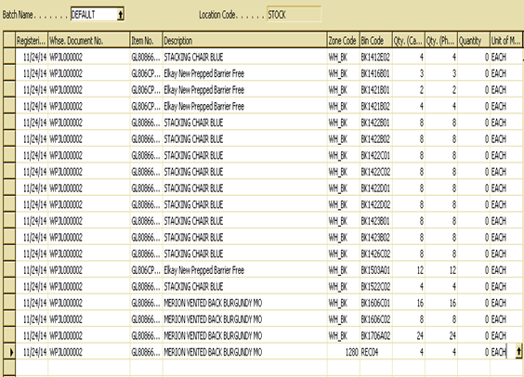

1. Once cycle count is complete, enter the cycle count values (refer to OPS08 - QF20, ‘First Count Sheet’ or the values from OPS08 - QF21 ‘Second Count Sheet’ into field Qty. (Phys. Inventory)

NOTE: If value in field “Qty. (Phys. Inventory)” is different from “Qty. (Calculated)”, the difference will automatically populate in field “Quantity”

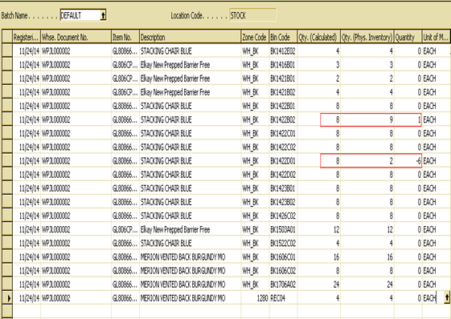

1. In the ‘Reason Code’ column Enter “CC” and then register the counts by:
   * 1. Registering
     2. Register or Register and Print

NOTE: Keyboard Shortcut: F11 or Shift + F11

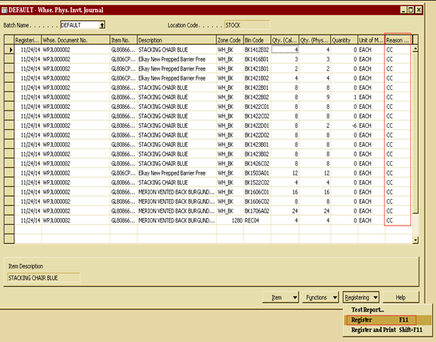

1. Go to ‘Phys.Inventory Journals’ by:

Warehouse → Inventory → Phys. Inventory Journals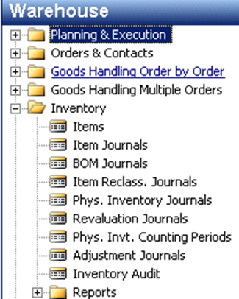

1. In Whse. Phys. Invt. Journal, go to:
   * Functions → Calculate Inventory

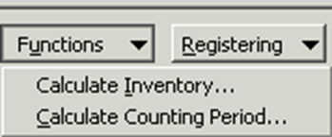

1. Enter Item number in field ‘Item No.’

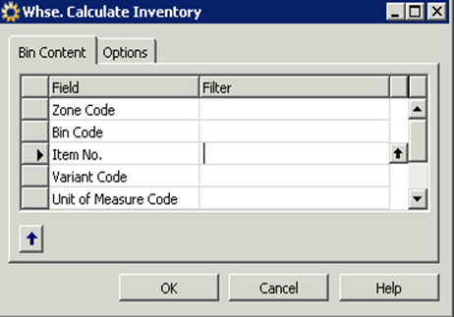

1. Based on the counts that were entered in ‘Whse.Phys.Invt.Journals’ in Step 5, entries will automatically be populated with required balancing values in field ‘Quantity’.
2. For example: If System’s quantity is 80, and Physical count is 75, Quantity displays 5. This is the discrepant value between system and physical.
   * 1. In the ‘Reason Code’ column enter “CC”
     2. In the ‘Department Code’ column, enter customer name
     3. In the ‘Gen. Bus. Posting Group’ column, enter customer name

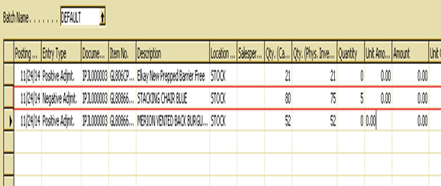

NOTE: Then post the counts by:

* + 1. Go to ‘Posting’
    2. ‘Post or Post and Print’
    3. Keyboard Shortcut: F11 or Shift + F11

1. Go to ‘Item Card’. Find the item for which the cycle count was performed and go to:
   * + 1. Go to ‘Functions’
       2. Choose ‘Calculate Counting Period’

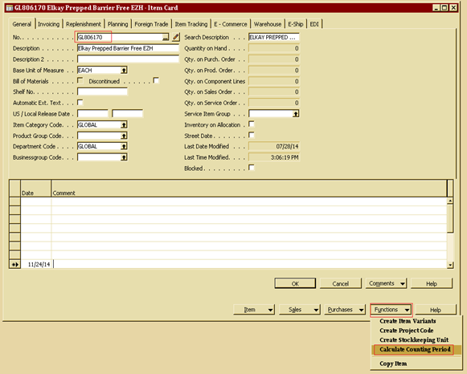

1. Navision will automatically update the information as to when to perform the next cycle count.

NOTE 1: Cycle counting process will be maintained and managed based on the requirements per customers’ SLAs or KPIs or as required

NOTE 2: Customer Cycle Count information is visible on the Item Card and can be viewed as follows:

* + - 1. Go to tab ‘Warehouse’ on item card
      2. Information regarding cycle counts can be found in area highlighted in Figure 13.

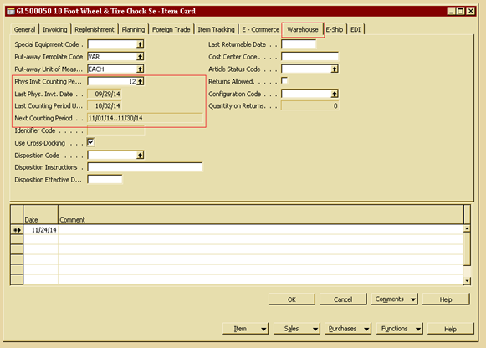

# 7.0 references

# 8.0 revision history

|  |  |  |
| --- | --- | --- |
| **Revision #** | **Revision Date** | **Description** |
|  |  |  |